REPUBLIC OF TURKIYE
GRADUATE SCHOOL OF
ISTANBUL aREL uNIVERSITY
DEPARTMENT OF CHOOSE PROGRAM

THESIS TITLE HERE
GRADUATE DEGREE
name surname

iSTANBUL, touch for the date
REPUBLIC OF TURKIYE
GRADUATE SCHOOL OF
ISTANBUL aREL uNIVERSITY
DEPARTMENT OF CHOOSE PROGRAM
THESIS TITLE HERE
GRADUATE DEGREE
name surname

supervısor: TITLE name surname
iSTANBUL, touch for the date
To Directorate of the Graduate School,
This work, prepared by wrıte your name surname, has been approved by jury as a GRADUATE DEGREE in Choose Program.

Jury Members | Signature
Supervisor  Title Name Surname and University | ………………………………………...
Co-supervisor  Title Name Surname and University Delete If not exits | ………………………………………...
Member  Title Name Surname and University | ………………………………………...
Member  Title Name Surname and University | ………………………………………...
Member  Title Name Surname and University | ………………………………………...

Approvement
I confirm that the above signatures belong to the aforementioned faculty members.
………………………………………….
TITLE NAME SURNAME
Director of Graduate School
Oath statement
I hereby declare that all information in this document has been obtained and presented in accordance with academic rules and ethical conduct. I also declare that, as required by these rules and conduct, I have fully cited and referenced all material and results that are not original to this work.

Touch for the date
WRITE YOUR NAME SURNAME IN BOLD AND SIGN

ABSTRACT
tItle of the thesIs
choose your DEGREE
name and surname of the author
GRADUATE SCHOOL, ISTANBUL AREL UNIVERSITY
DEPARTMENT OF CHOOSE PROGRAM
TYPE OF BRANCH SCIENCE/ART FIELD
(SUPERVISOR: TITLE NAME SURNAME )
(co-SUPERVISOR: if there is no co-supervisOr delete this)
İSTANBUL, ınsert the date here
Start typing the abstract from here… The abstract should not exceed one page, including keywords. For this reason, the content should be briefly introduced and the author should inform the reader about the problem that constitutes the core of the research subject, the method used in the research, the findings and results obtained on this page. When translating the Turkish text given in the "OZET" part of the thesis to English, it is expected to have the same content as in the "OZET" part.
In writing the titles of faculty members; (Prof. Dr.- Prof. Dr.); (Doç. Dr.- Assoc. Prof. Dr.); (Dr. Öğr. Üyesi - Assist. Prof. Dr.) abbreviations should be used. Keywords related to the thesis should be written in English after the "Key Words". Since the “OZET” and “Abstract” pages will be uploaded to the Higher Education Institution's Thesis Database, subtitles, figures, tables, references, footnotes, italic fonts, graphics, chemical or mathematical formulas, symbols, subscripts and superscripts or other non-standard characters should not be used in this page.
Key Words:

ÖZET
TEZ BAŞLIĞINIZI BURAYA YAZINIZ
LİSANSÜSTÜ Programınızı seçiniz
adınızı soyadınızı YAZINIZ
İSTANBUL AREL ÜNİVERSİTESİ LİSANSÜSTÜ EĞİTİM ENSTİTÜSÜ
PROGRAM SEÇİNİZ
BİLİM DALI SEÇİNİZ
(DANIŞMAN: ÜNVAN Adı soyadı )
(eş DANIŞMAN: eşdanışman yoksa bu alanı siliniz)
İSTANBUL, TARİH İÇİN DOKUNUN
Özet metni yazmaya buradan başlayınız… Özet metni anahtar kelimelerde dahil olmak üzere bir sayfayı aşmamalıdır. Bu sebeple içerik kısaca tanıtılmalı ve yazar bu sayfada okuyucuya araştırma konusunun özünü oluşturan problem, araştırmada kullanılan yöntem, elde edilen bulgular ve sonuçlar hakkında bilgiler vermelidir. Özet ve Abstract sayfaları Yüksek Öğretim Kurumu Tez Veri Tabanındaki taranabilir alanlara yükleneceğinden, alt başlık, şekil, tablo, kaynak, dipnot, italik yazı tipi, grafik, kimyasal veya matematiksel formüller, semboller, alt ve üst simgeler veya diğer standart olmayan simge ve karakterler kullanılmamalıdır.
Özet sayfasının altına “Anahtar Kelimeler” ibaresi 12pt boyutunda koyu harfli olacak şekilde yazılmalıdır. Anahtar kelimelerin sayısı 3 ile 7 adet arasında olmalıdır. Anahtar kelimeler 12pt boyutunda yazılmalı ve aralarında virgül olmalıdır. Sayfa numarası 12pt boyutunda “i” olup sayfanın altında ve ortalanmış olarak verilmelidir.
Anahtar Kelimeler:

TABLE OF CONTENTS
Page
ABSTRACT i
ÖZET ii
TABLE OF CONTENTS iii
LIST OF FIGURES v
LIST OF TABLES vi
ABBREVIATIONS AND SYMBOLS vii
PREFACE viii
1 INTRODUCTION 1
1.1 Example Second Level Subtitle 1
1.1.1 Example Third Level Subtitle 1
1.1.1.1 Example Fourth Level Subtitle 1
1.1.1.2 Example Fourth Level Subtitle 2
1.1.1.2.1 Example Fifth Level Subtitle 2
2 PRINCIPLES AND CONCEPTS 3
2.1 Basic Principles 3
2.2 Advisor of Thesis 3
2.3 Masters Thesis 4
2.4 Ph.D. Thesis 4
2.5 Proficiency in Art 5
3 THESIS GUIDELINES 6
3.1 Introduction and Objective 6
3.2 Language of Thesis 6
3.3 Paper Specifications for Thesis Printing 6
3.3.1 Writing Format and Page Layout 6
3.4 Font and Size 7
3.5 Adding Figures and Table Captions 7
3.6 Quotation of Table or Figure in the Text 9
3.7 Procedures in the Thesis Process 11
3.7.1 Before the Examination 11
3.7.2 After the Examination 11
3.7.2.1 Obtaining an Orcid Number 12
3.8 Chapters of Thesis 12
3.9 The Similarity Ratio (Plagiarism) in Thesis 13
3.10 Table of Contents Page 13
3.11 Other Lists 14
3.12 Page Layout 14
3.13 Paragraph Layout and Line Spacing 14
3.14 Figures, Tables and Pictures 14
3.15 Equations 15
3.16 Footnotes 16
4 INTEGRATED ILLUSTRATION OF THE THESIS 17
4.1 Front Pages 18
4.1.1 Cover Pages 18
4.1.2 Oath Statement Page 18
4.1.3 Abstract Page 18
4.1.4 Özet Page 18
4.1.5 Table of Contents Page 19
4.1.6 List of Table, Figure and Abbreviations and Symbol Pages 19
4.1.7 Preface Page 19
4.2 Chapters of Thesis 30
4.2.1 Introduction 30
4.2.2 Other Chapters 30
4.2.3 Conclusion and Recommendations 30
5 METHODS (If any) 36
6 FINDINGS (If any) 37
7 CONCLUSION AND RECOMMENDATIONS 38
7.1 Conclusions 38
7.2 Recommendations 38
8 REFERENCES 39
8.1 Citation to References in Main Text 39
8.2 Organization of References 41
8.2.1 Presentation of Books in the Reference List 42
8.2.2 Presentation of Periodicals in the Reference 43
8.2.3 Presentation of Conference (Congress) Papers 44
8.2.4 Presentation of Unpublished Thesis 44
8.2.5 Presentation of Internet Sources 44
8.2.6 Presentation of Encyclopedias in the Reference List 45
8.2.7 Presentation of Dictionaries in Reference List 45
8.2.8 Presentation of Scriptures in Reference List 45
8.2.9 Presentation of Court Decisions in Reference List 45
8.2.10 Presentation of Newspapers in Reference List 46
8.2.11 Presentation of Newspapers Movies or Videos in Reference List 46
9 APPENDIX (If any) 47
Appendix A Supplement with thesis (if any) 47
10 CURRICULUM VITAE 48

LIST OF FIGURES
Page
Figure 3.1 İstanbul Arel University logo. 7
Figure 3.2 Second İstanbul Arel University logo. 8
Figure 3.3 Addition of figure/table caption 8
Figure 3.4 Example of Table caption 9
Figure 3.5 Cross-reference to table/figure in the text 9
Figure 3.6 Example pictures from cross-reference windows 10
Figure 3.7 Cross-reference of figure 10
Figure 4.1 Example for outer cover page 20
Figure 4.2 Example for inner cover page 21
Figure 4.3 Example for Oath statement page 22
Figure 4.4 Example for Özet page 23
Figure 4.5 Example for Abstract page 24
Figure 4.6 Example for table of contents page 25
Figure 4.7 Example for list of figures page 26
Figure 4.8 Example for list of tables page 27
Figure 4.9 Example for abbreviations and symbols page 28
Figure 4.10 Example for preface page 29
Figure 4.11 Example for Introduction and sub sections -1 31
Figure 4.12 Example for conclusion and recommendations page 34

The “List of Figures” is an index that follows the “Table of contents” in which the numbered figures are presented in order. Figure numbers should be given according to order of figures within the related section (Example: Figure 2.1 Waste source). Figure numbering is explained in section 3.5 of this guideline. This list is prepared automatically by right-clicking anywhere in the list and selecting the "Update Field" option if the figure numbering is prepared according to Section 3.5.
These descriptions should be deleted after the list of figures is prepared.

LIST OF TABLES
Page
Table 3.1 Example Table 9
Table 4.1 Chapters of thesis 17

List of Tables is an index in which numbered tables are presented in order. Table numbers should be given according to order of tables within the related section (Example: Table 3.3 Statistical table). Table numbering is explained in section 3.5 of this guideline. This list is prepared automatically by right-clicking anywhere in the list and selecting the "Update Field" option if the table numbering is prepared according to Section 3.5. These comments should be deleted after the List of Tables is created.

ABBREVIATIONS AND SYMBOLS
Symbol | : | The name of symbol or explanation
Symbol | : | The name of symbol or explanation
Abbreviation | : | Explanation of abbreviation

“Abbreviation and Symbols” is an example list. This list is an index where the abbreviations and symbols used in the thesis are given in order. The title of this page, “ABBREVIATIONS AND SYMBOLS”, should be written in capital letters, in bold, in 14pt font size, centered from the top of the text area, without leaving any spaces. This index can be deleted if there are no Abbreviation and Symbols in the dissertation.
The index should be written with two one-line spacing. The page number containing the symbol should not be given in the index. Only abbreviations and symbols should be written and introduced. While preparing this list, the format given above should not be distorted.
12pt character size and one-line spacing should be used while creating this index. In addition, Symbols are written in bold while their descriptions are not written in bold. These comments should be deleted after the Symbol List is created.

PREFACE
Add the preface here. This page is an acknowledgment page that briefly explains the positive or negative conditions that the author faced during the thesis process, the support he received from his environment in these circumstances, and from whom (or from which organizations) he received this support (with their titles, if any).
The title of the page should be written as “PREFACE” in bold, in 14pt size, centered without leaving any spaces from the top. After leaving two 1 line spaces, text writing should be started from within 1 tab. The font style of the text in this section should be “Normal” in Styles.
The preface should not exceed one page.
This thesis has been supported by Write the supporting organization here with write the project number here project number.

Touch for the date
WRITE YOUR NAME AND SURNAME IN BOLD AND SIGN

INTRODUCTION
This section is the first section that should exists in all dissertations.
In this section, the following sub-headings are expected to be included in the study: Problem definition, Aim and Scope, and Research Method. In addition, in this section, the presentation of the main section in the study/thesis (using the Sub-title of the Study Plan) should be made.
To write a first-level section title, you must select the Heading 1 style. For example: We would like to write the second section "2. THESIS WRITING GUIDE". For this, first write “THESIS WRITING GUIDE” in capital letters without numbering the title and select the Heading 1 style from the styles section.

Example Second Level Subtitle
To write a second level subsection title, you must select the Heading 2 style. For example: We want to write the section “1.1 Example Second Level Subtitle”. For this, using the first letter of each word capitalized without numbering the title, first write “Example Second Level Subtitle” and select the Heading 2 style from the styles section.

Example Third Level Subtitle
To write a third level subsection title, you must select the Heading 3 style. For example: We want to write the section “1.1.1 Example Third Level Subtitle”. For this, using the first letter of each word capitalized without numbering the title, first write “Example Third Level Subtitle” and select the Heading 3 style from the styles section.

Example Fourth Level Subtitle
To write a fourth level subsection title, you must select the Heading 4 style. For example: We want to write the section “1.1.1.1 Example Fourth Level Subtitle”. For this, using the first letter of each word capitalized without numbering the title, first write “Example Fourth Level Subtitle” and select the Heading 4 style from the styles section.

Example Fourth Level Subtitle
You can make fourth-level subsection headings in the same way as second- and third- or fourth-level subsection headings, as given above.

Example Fifth Level Subtitle
To write a fourth level subsection title, you must select the Heading 5 style. For example: We want to write the section “1.1.2.1 Example Fifth Level Subtitle”. For this, using the first letter of each word capitalized without numbering the title, first write “Example Fifth Level Subtitle” and select the Heading 5 style from the styles section.

PRINCIPLES AND CONCEPTS
This guide has been prepared to specify the rules while writing the thesis for the students of Istanbul Arel University, Graduate School. The guide emphasizes the content requirements of dissertations. In addition, this guide has been prepared as a Word document to form integrity of the dissertations and ease of writing. This Word document must be used while writing the thesis following writing rules and styles described in the guide.
The student must carefully read and fulfill the requirements of the Istanbul Arel University Graduate School Education and Examination Regulations (click for the document) and this guide.

Basic Principles
The rules of academic ethics should be strictly adhered during the preparation of the thesis. The student should prepare his/her own thesis. The rules of citing and quoting must be strictly followed. Research data should be obtained from reliable sources and should not be corrected or changed for any reason.
There is no general rule about how many pages of a thesis. The views and comments of the author in the thesis should be clear and understandable, leaving no room for doubt.

Advisor of Thesis
Advisor of thesis is the appointed among the faculty members who guides the student with his experience, level of knowledge, role model in the whole process from selection of study subject to the defense of the study and supervises it in terms of academic principles. The advisor is obliged to show the interest and allocate time to ensure that the student completes his/her program on time. It is recommended that the students should at least meet with his/her advisor once a month while preparing his/her thesis.

Masters Thesis
The aim of the master’s Program is to develop theoretical and practical knowledge, to produce new information by scientific research, to evaluate and interpret information, to gain a scientific perspective on problems and solutions for the student in the related field. The student proves that they have reached this level by completing their coursework and submitting an acceptable master’s thesis.
Master's thesis is a scientific study presented in written form, which includes scientific research to produce, evaluate and interpret new information by using the theoretical and practical knowledge and skills that has acquired by the student.
It is expected that master's thesis is based on scientific research in a certain field, investigating the relationships between the phenomena, identifying the problems, and bringing original solutions and suggestions to them. The distinguishing feature of the master’s thesis in terms of quality and academics is that it is based on scientific research compared to master’s project. It is desired that the master's thesis has the standards to produce a scientific article.

Ph.D. Thesis
The aim of the Doctorate Program is to provide the deepest and broadest theoretical and applied scientific knowledge and skills enable to conduct independent scientific research, to interpret scientific events by examining them, to produce new information and original alternative solutions for the students. If the process is successful, the student is accepted as a "Doctor" in the related field. The student proves that they have reached this level by completing their coursework and submitting an acceptable doctoral thesis. It is expected that doctoral thesis brings innovation to science, develops a new scientific method, or ensures the application of known method to the new fields.
The distinctive feature of doctoral thesis is based on deep scientific research in a narrow and specific field compared to master's thesis. It is essential that the doctoral thesis must produce at least one scientific article.

Proficiency in Art
The Proficiency in Art aims to enable designer and artist candidates to become contemporary, creative, cultured, competent designers or artists who develop the aesthetic values of society through art and design by researching the knowledge, methods and techniques in their fields of work. After the course period, the student presents his/her Proficiency in Art Thesis by making deep research within the framework of an interdisciplinary understanding in a specific field. The student completes the program, offering an innovative contribution to the disciplines of thought and practice in the fields of design and art by proficiency in art thesis.
The Proficiency in art thesis is written in accordance with this guide accepted by Istanbul Arel university Graduate School and the original art/design work related to the subject of the thesis is included in a part of the thesis. The student is obliged to present the original artwork related to the subject of thesis and make an oral defense to the examining committee.

THESIS GUIDELINES

Introduction and Objective
This guide has been prepared to provide a certain standard, to determine and exemplify the principles and formal qualifications to be followed in the writing of Proficiency in Art, master’s and Doctorate theses to be prepared in the Graduate School of Istanbul Arel University. This document should be perceived as a guide for authors to prepare their thesis in accordance with the principles of scientific presentation. Since each branch of department has academic differences, the authors can benefit from their own majors, if they comply with the basic rules (such as writing style, cover pages, etc.) They can apply the diversity that comes from their own majors, protecting the unity.

Language of Thesis
The language of the Proficiency in Art, Master's and Doctorate theses, which will be prepared in the Graduate School of Istanbul Arel University, must be Turkish or English.

Paper Specifications for Thesis Printing
The papers used in writing the thesis are in A4 standard (210 x 297 mm. dimensions) and at least 70 gr. at most 100 gr. The prime white paper and only one side of the paper should be used. The characters in the text should be in black. The printer used to print the thesis should be a cartridge or laser printer. Reproductions should be made by photocopying on high quality white paper, the texts and figures in the reproduced copies should be clear and legible.

Writing Format and Page Layout
Computer should be used for writing. If desired, "italic" font can be used in the parts of the thesis that need to be specifically mentioned. Other characters are not accepted.

Font and Size
Microsoft Word should be used in computer writing of theses. The font should be “Times New Roman” and the font size should be “12 point”. In the template for which the example is given, this font style is included as "Normal" as standard. In other words, the writing style of the texts should be "Normal" during the writing of the thesis. After typing chapter headings and subsection headings or figure or table numbers, pressing the “Enter” key on the keyboard automatically switches to this writing style. However, when wide and/or long tables are required to fit on a single page, 9- or 8-point size letters can be used in tables. Outer cover and second cover font sizes are set automatically and cannot be changed. Microsoft Word 2007 or a later version should be used for preparing thesis.
A space should be left after the punctuation marks. Author must comply with the English spelling and punctuations.

Adding Figures and Table Captions

Figure 3.1 İstanbul Arel University logo.
To add a caption to a picture or figure, right-click on the picture and select "Add caption". In the window that opens, the figure number will appear automatically. If you encounter the statement "No text in the style specified in the document", right-click on the error text and select "Edit Field" from the pop-up menu. In the window that opens, select Title 1 in the "Style Name:" pane and press the "OK" button. Then enter the shape description or name you want. Make sure that the figure number and figure description writing style is “Caption”. Then, select “Figure 2.1” which should be bold and bold it. For this figure to appear in the figure list, enter it in the figure list. Right click anywhere and select "Update Field".
Figure 3.2 Second İstanbul Arel University logo.
An example table (see Table 2.1) is given below. You can prepare the table according to the following format. To add a table caption, go to the line above the table. Then click on Add caption under the “References tab” Click on add caption. A screen like Figure 2.3 will appear.
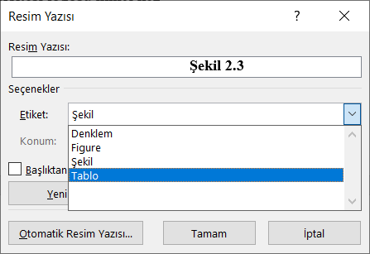
Figure 3.3 Addition of figure/table caption
As seen in Figure 3.3, the “Table” option under the Label option is clicked and the Table number is placed in your location (see Figure 3.4). Then type the table description or name you want. Make sure that the writing style of the table number and figure description is "Resim Yazısı". Then select “Table 2.1” which should be bold and bold it. For this table to appear in the table list, enter the figure list. Right click anywhere and select "Update Field".
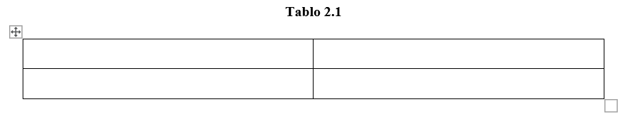
Figure 3.4 Example of Table caption
An example table is shown below.
Table 3.1 Example Table
Example Table Title | Example Table Title 2
1 | aa
2 | bb
3 | cc

Quotation of Table or Figure in the Text
Tables and/or figures are frequently used in the writing process of the thesis. The figures and/or tables used must be cited in the thesis. In this process, sometimes the order of tables and/or figures changes, and in this case, the numbers of figures and/or tables change. In these changing conditions, tables and/or figures naturally change in citations in the text. To be affected by these changing conditions at the minimum level, the tables and/or figures used can be automatically quoted in the text. In this section, how automatic quoting can be done is expressed visually.
For example, if you want to automatically quote Figure 2.1 and Table 2.1 given in Section 2.5, the steps to be taken should be as follows:
Go to the place where the citation will be made and select the "Cross-reference" option under the "References" tab (see Figure 3.5).
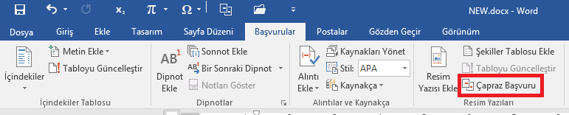
Figure 3.5 Cross-reference to table/figure in the text

After selecting “Cross-reference”, the following screen will appear. This screen refers to the type of reference to be quoted in the text, and the data under the "which item" tab changes according to the selected section. The expression given in “Reference type” will change when a figure or table is selected. For example: if the shape is selected, it will appear as “For which caption:”. If the sections to be quoted is “Numbered item”, if it is a figure, “Figure”, if it is a table, “Table” or if it is an equation, “Equation” option is selected in the Reference type section.
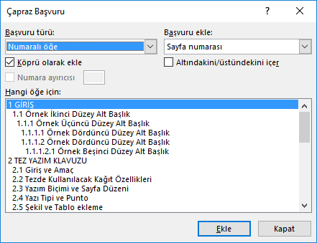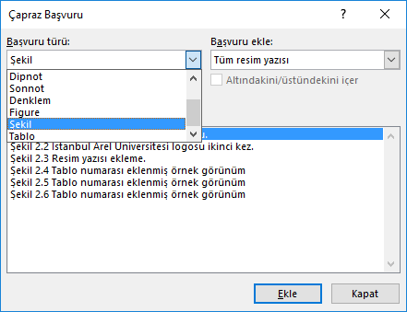
Figure 3.6 Example pictures from cross-reference windows
After selecting the relevant “Reference type”, the item to be quoted is selected. If “Figure 2.1” was desired to be quoted, then, under the "Add reference" tab, the "Only label and number" should be selected since only the figure and/or table number will be quoted in the text. Thus, the figure and/or table label and number to be quoted will be quoted.
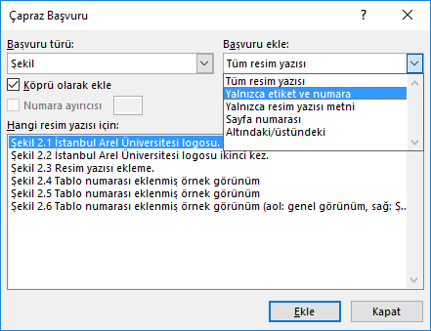
Figure 3.7 Cross-reference of figure
After the necessary operations are completed, click "Add" option so that the table and/or figure to be quoted in the text.

Procedures in the Thesis Process

Before the Examination
Electronically prepared thesis should be brought to the Graduate School with "Thesis Submission Form", indicating that the thesis has been prepared in accordance with this guideline for the first control. The thesis submission form should also include a proposal for the thesis exam date determined by the thesis advisor. Relevant forms can be obtained from the website. After the confirmation of the thesis, the student must forward the unbound thesis to the Jury and alternative jury members.

After the Examination
Electronic copy of the thesis should be sent to the Graduate School for the final control including jury members corrections within one month. This process is repeated until errors are fixed. After this process is completed, the following steps should be performed.
Proficiency in Art, Master’s, and Doctoral Students,
- Jury signature page (2 copy),
- Hardcover thesis (1 copy),
- Student ID,
- Clearance Certificate signed by the relevant units,
Should be submitted to Graduate School.
- Completed thesis should be submitted to Graduate school in PDF format installed in CD-ROM (For hybrid thesis defenses). In PDF file, all pages should be unsigned. The file size should be maximum 100 MB per file.
- Thesis Data Entry Forms should be prepared. This form must be filled electronically from e-devlet, printed, and signed to submit to the Graduate School. The author must also obtain an ORCID number while entering the thesis data. How to get the ORCID number is given in section 3.7.2.1.

Obtaining an Orcid Number
According to the decision taken by YÖK, an ORCID number is required for all theses submitted to the Graduate School of Istanbul Arel University. The ORCID number should be added to the "Curriculum Vitae" section. Our students are recommended to follow the roadmap to obtain an ORCID number:
• Go to YÖK National Thesis Center (https://tez.yok.gov.tr/UlusalTezMerkezi/) web page.
• Click on the "MEMBER LOGIN" button in the upper right corner.
• Log in to the system with your e-devlet password.
• After clicking on the "THESIS DATA ENTRY FORM" section on the your profile information page, your thesis information will appear in the window.
• After selecting the thesis for which you want to get an ORCID number, you can fill in the required fields on the form and click "GET ORCID NUMBER".

Chapters of Thesis
The content of the thesis may vary in the Graduate School of Istanbul Arel University due to the academic differences in the departments which the thesis is prepared. Due to this diversity, chapters of thesis may vary according to department except two main chapters given below. The first chapter of the thesis about the academic content is the "Introduction" chapter and the last main section is the "Conclusion and Recommendations" section. The order of the remaining chapters is left entirely to the authors. In addition, explanations about the contents of the thesis/study are given in Section 4.

The Similarity Ratio (Plagiarism) in Thesis
Proficiency in Art, Masters and Ph.D. theses are plagiarized after they are submitted to the Graduate School. Plagiarism check is carried out by Graduate School of Istanbul Arel University. The result of the Plagiarism Report is sent to the thesis advisor. The similarity rate is expected to be below 20%, excluding REFERENCES.
If similarity rate is exceeded this ratio due to the academic differences in the Major Science/Major Art branches, the thesis advisor should fill the "Consultant Plagiarism Evaluation Form" published on the home page the Graduate School, together with a justified explanation and approval of the plagiarism rate. The thesis can be exempted from this rate after evaluation.

Table of Contents Page
The table of contents is an index in which all chapters in the thesis are given by page numbers, starting from the Abstract page. “TABLE OF CONTENTS”, which is the title of this section, should be written in bold, 14pt font size, centered on the page without leaving any spaces at the top of the text area. The page number is “iii” in 12pt size and should be at the bottom of the page and in a centered format.
This section is presented ready-made for students. No changes should be made to styles or page layout. After the sections of the thesis are prepared, right-click on anywhere of the index and click on "Update Field" tab on the page and the page is automatically updated. The title of each main section and subsection of the main section used in the text of the thesis, together with its number, should be placed on this page completely without any change in the form of expression. Italic characters should not be used.
Abstract, Özet, Table of Contents, List of Figures, List of Tables, List of Abbreviations and Symbols, Preface, Introduction, Main Chapter Titles, References and Appendices on this page should all be written in capital letters and bold. The first letter of each word in the subsection titles (except for conjunctions with and, or, and etc.) should be capitalized and the other letters should be lowercase.

Other Lists
As mentioned before, each major may have its own differences. Therefore, authors may need to add directories or lists other than the ones given in this document to their thesis. In this case, the authors should prepare these lists in accordance with the rules given above.

Page Layout
There should be 4 cm margin from the left edge and 2.5 cm from the other edges for each page. In the thesis text, syllable splits should not be made at the end of the lines and the writing of the thesis text should be in the justify order.

Paragraph Layout and Line Spacing
In the text of the thesis, paragraphs should be started in 1 tab inside from left. 1.5 line spacing should be used in the main text of the thesis and 1 line spacing should be left between adjacent paragraphs. All these settings are available in “Normal” style.

Figures, Tables and Pictures
Figures, tables, and pictures should be centered within the text and, if possible, they should be mentioned in the text of same or the next page. Figures, tables or pictures that are in a state of overflow should either be reduced or presented under the heading “APPENDIX”. If figures longer than one page must be included in the thesis text, they can be divided according to one page size and given on the next page. In this case, the figure title should be given by writing "continued" after the number in parentheses, keeping the number and title the same. For example, “Figure 3.4 (continued)”.
Numbering and explanation should be made below the figures and pictures, and above the tables. The first digit (first letter in the annexes) should be numbered consecutively, with the number of the Chapter where the figure, table or picture is located, and the second number/numbers should be in the sequence of the table, picture or figure within the same Chapter. The numbers of the subsections should be disregarded. For example, Figure 6 of Chapter 3 should be written as “Figure 3.6” or Table 3 of Appendix A should be written as “Table A.3”. “Resim Yazısı” style should be used in writing the table or figure number and description. Explanation is not necessary. Explanations of figures, tables and pictures should be written with a space after the number and only the first letter of the first word should be written in capital letters, other words should be written in lower case and not “bold”. For example, “Şekil 3.2 Yarı grupların sonlu temsil edilebilirliği”.
If three or more related illustrations need to be on the same page, the letters (a), (b), (c), ... should be placed on each of them in order, each should be given a single table or figure number and explained separately. For example,
Şekil 2.2 Explanation a) Explanation of a, b) Explanation of b, c) Explanation of c.
Figures that cannot be created eletronically should be drawn according to technical drawing principles, text and symbols should be written with a template and no manual correction should be made. When referring to figures, tables and pictures within the main-text, the first letter should be capitalized. In addition, in the referencing, if the mentioned figure is on the referenced page or the next page, the reference should be as shown in the examples below.
Example; Bu yapıların yazısı Şekil 2.2’de verildiği gibidir.
Example; Bu yapıları genel olarak 3 gruba göre sınıflandırabiliriz (Şekil 2.2).
If it is necessary to refer to the figures and tables that have been mentioned and included in the previous pages or any page of the thesis, the ebbravations "see"should be used.
Example; Bu yapıları genel olarak 3 gruba göre sınıflandırabiliriz (see Figure 2.2).

Equations
The equations should be centered in the page. 1 line spacing should be used in the writing of the equations. First digit of equations is the Chapter number and second digit starting from "1" is the sequence number of the equations, regardless of the numbers of the subsections. Equation number should be written in parentheses and right aligned to the page. For example, equation 10 of Chapter 3 should be written in the form (3.10).
$$f\left(x\right)=a_{0}+\sum_{n=1}^{∞}{\left(a_{n}\cos{\frac{nπx}{L}}+b_{n}\sin{\frac{nπx}{L}}\right)}$$ | (3.1)
Long equations which do not fit on a single line can be splinted by the author at appropriate places. Referencing to the equations in theses should be as follows.
Yapının çözümü (1.15) eşitliği yardımıyla hesaplanabilir.

Footnotes
Footnotes should not exceed several lines. Footnotes should be start from "1" for each page and superscripted above the relevant word. The footnote should remain within the text writing area of the page and should not exceed the 2.5 cm space of bottom edge of the page. 1 line spacing should be used in the writing and the letter size should be 8pt-10pt.
The text should be separated from the bottom of the page with a continuous line drawn from left to right, after leaving a space of 1 line from the text.
The first line of the footnote should start with the footnote number 1 tab inside. Two footnotes should be written in 1 line spacing without any spaces. If more than one footnote is used on the page, they should be sorted according to their order in the page. Footnotes should not be used to cite references but should only be used for special explanations or descriptions.

...........bu tür malzemelerin yapılarının¹ genel özellikleri ……………… ……………………...……………………………………………………biçimindedir.

¹Malzeme yapıları üzerinde çalışan çok önemli konulardan biri olup, …………. ……………………….. kullanılmaktadır.

INTEGRATED ILLUSTRATION OF THE THESIS
This document has been prepared as a Word file for students to use in writing for their thesis. In addition, explanations about the chapters of the theses are given in this section. The content of these may vary, as there are academic differences in the major science/main arts branches where the thesis/study is conducted. Taking this diversity into account, if the chapters given below in the table with the expression "(if any)" do not have to be included in the theses. Other sections/chapter must be included in the theses.
Table 4.1 Chapters of thesis
Outer Cover Page
Inner Cover Page
Jury Signature Page
OATH STATEMENT
ABSTRACT
ÖZET
TABLE OF CONTENTS
LIST OF FIGURES (If any)
LIST OF TABLES (If any)
ABBREVIATIONS AND SYMBOLS (If Any)
PREFACE
1. INTRODUCTION
2. MAIN CHAPTER TITLE
2.1 Subsection Title
2.1.1 Section of Subsection
……….
.
.
.
5. METHODS (If Any)
6. FINDINGS (If Any)
7. CONCLUSION AND RECOMMENDATIONS
8. REFERENCES
9. APPENDIX (If Any)
10. CURRICULUM VITAE
In addition, the integrated structure of the thesis/study are exemplified below with some examples of the chapters which must be in the thesis/study:

Front Pages
The outer and inner cover pages, Jury signature page, oath statement, abstract, özet, table of contents, list of figures, list of tables, abbreviation and symbols and preface are the front pages of thesis.

Cover Pages
The inner and outer cover pages are automatically generated for students and should be as given in this document. The student fills the required information in the places marked with red bold. The thesis name and author's name and surname should be written without specifying the title and the date of submission of the thesis should be selected. An example cover page is shown in Figure 4.1 and Figure 4.2.

Oath Statement Page
The student fills the required information in the places marked with red bold. A sample oath statement page is given in Figure 4.3.

Abstract Page
The abstract is brief introduce of the thesis. It is written in “English” and should not exceed one page, including the keywords. For this reason, the content should be briefly introduced, and the reader should be informed about the problem that constitutes the core of the research topic, the method used, the findings and results. Non-standard symbols and characters should not be used as the abstract will be uploaded to the Higher Education Institution Thesis Database. An example Abstract page is given in Figure 4.4.

Özet Page
This is the page where the English text on the abstract page is written in a Turkish language. The translation is expected to give the same content as on the Abstract page. An example Özet page is given in Figure 4.5. The Abstract page given in Figure 4.4 was used for translation.

Table of Contents Page
The Table of Contents is placed right after the “Özet” page in the structure of the thesis. It contains the chapter titles (with their subsections) included in the thesis. An example “Table of Contents” page is given in Figure 4.6.

List of Table, Figure and Abbreviations and Symbol Pages
Examples for Figure list, Table list and Abbreviation and Symbol pages are shown in Figure 4.7, Figure 4.8 and Figure 4.9, respectively. Each list starts as a separate page, i.e. on a new page. In this document, the relevant sections are presented for ready use.

Preface Page
In this section, the author can introduce the subject of the thesis, the reasons for the study and the stages during the study can be mentioned. The author expresses his gratitude briefly explaining (with titles, if any) from whom (or from which organizations) he received the support by mentioning the positive or negative aspects encountered during the thesis process. A sample Preface page example is given in Figure 4.10.


Figure 4.1 Example for outer cover page

Figure 4.2 Example for inner cover page

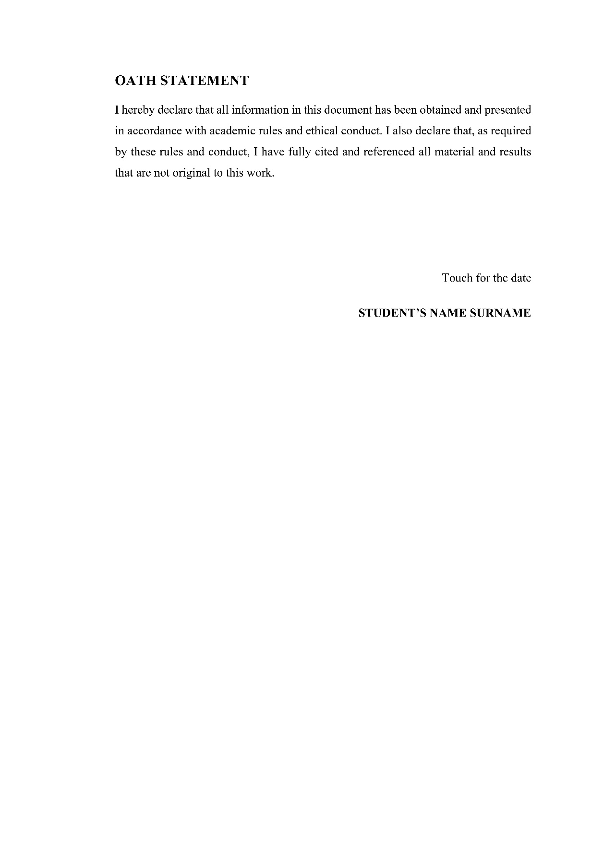
Figure 4.3 Example for Oath statement page
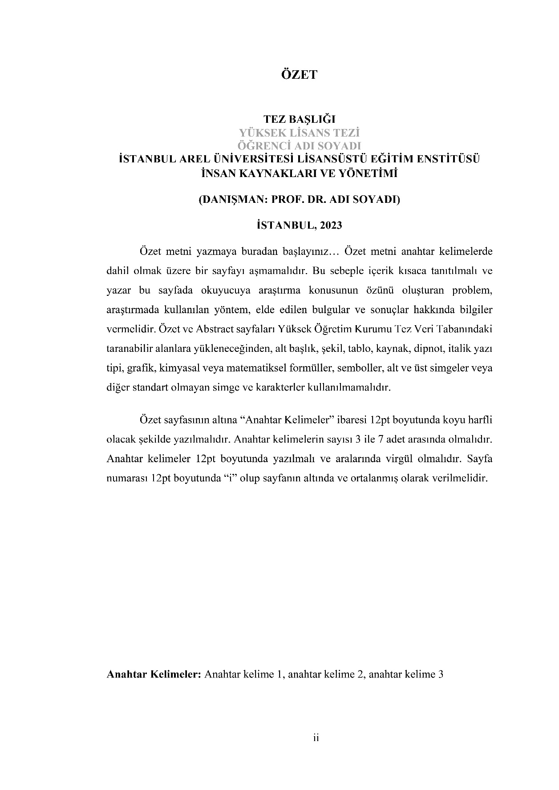
Figure 4.4 Example for Özet page
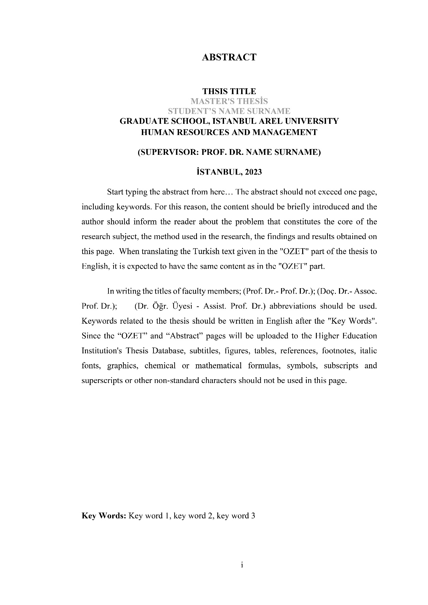
Figure 4.5 Example for Abstract page
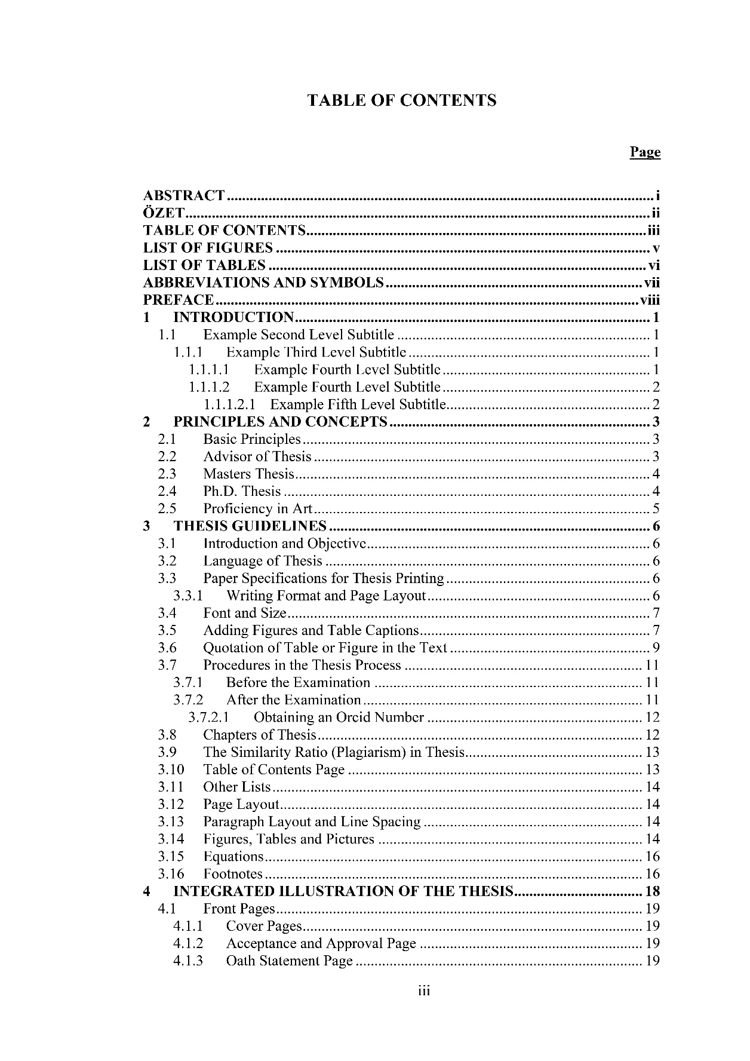
Figure 4.6 Example for table of contents page
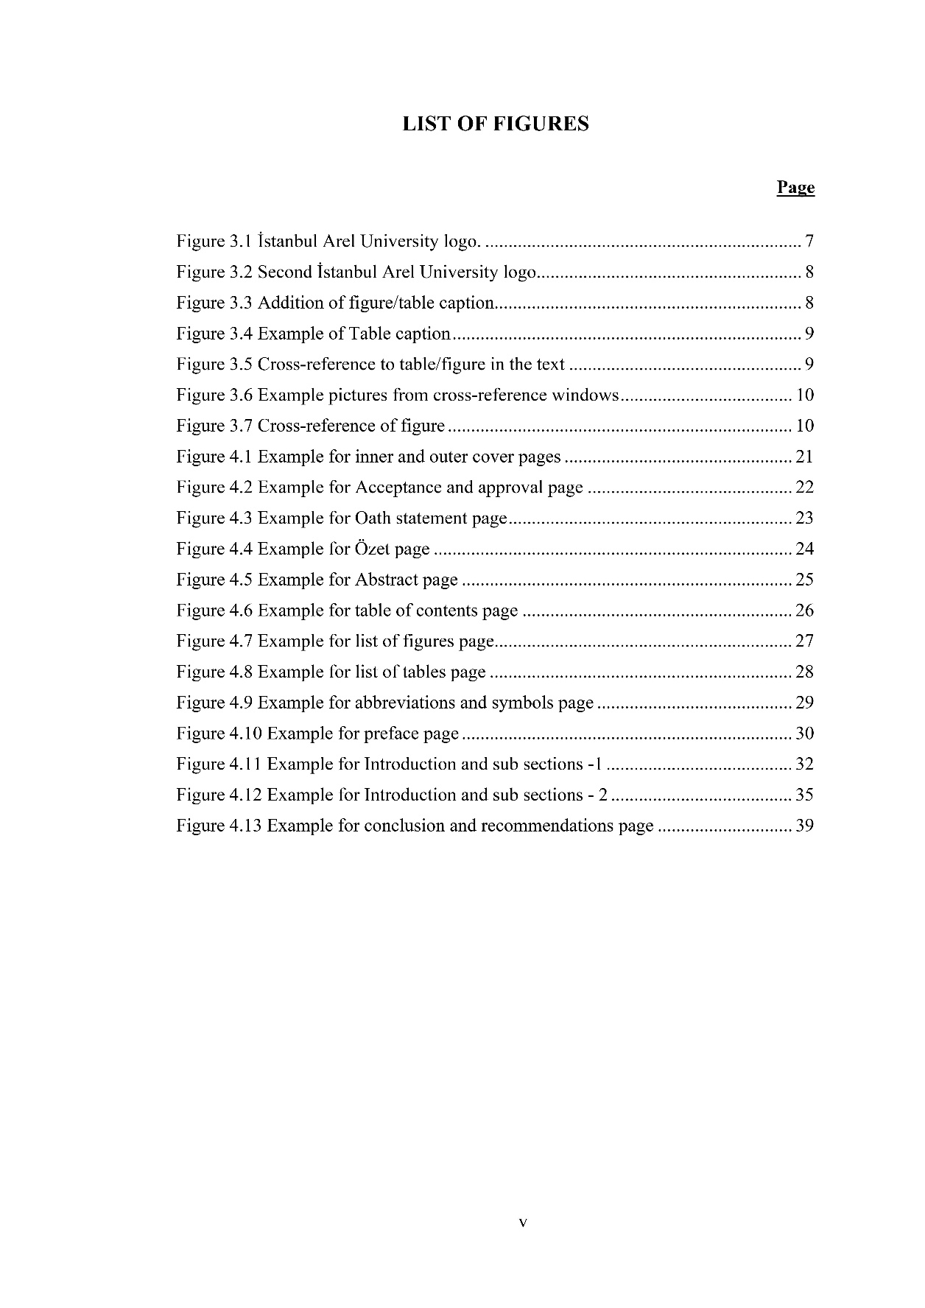
Figure 4.7 Example for list of figures page

Figure 4.8 Example for list of tables page
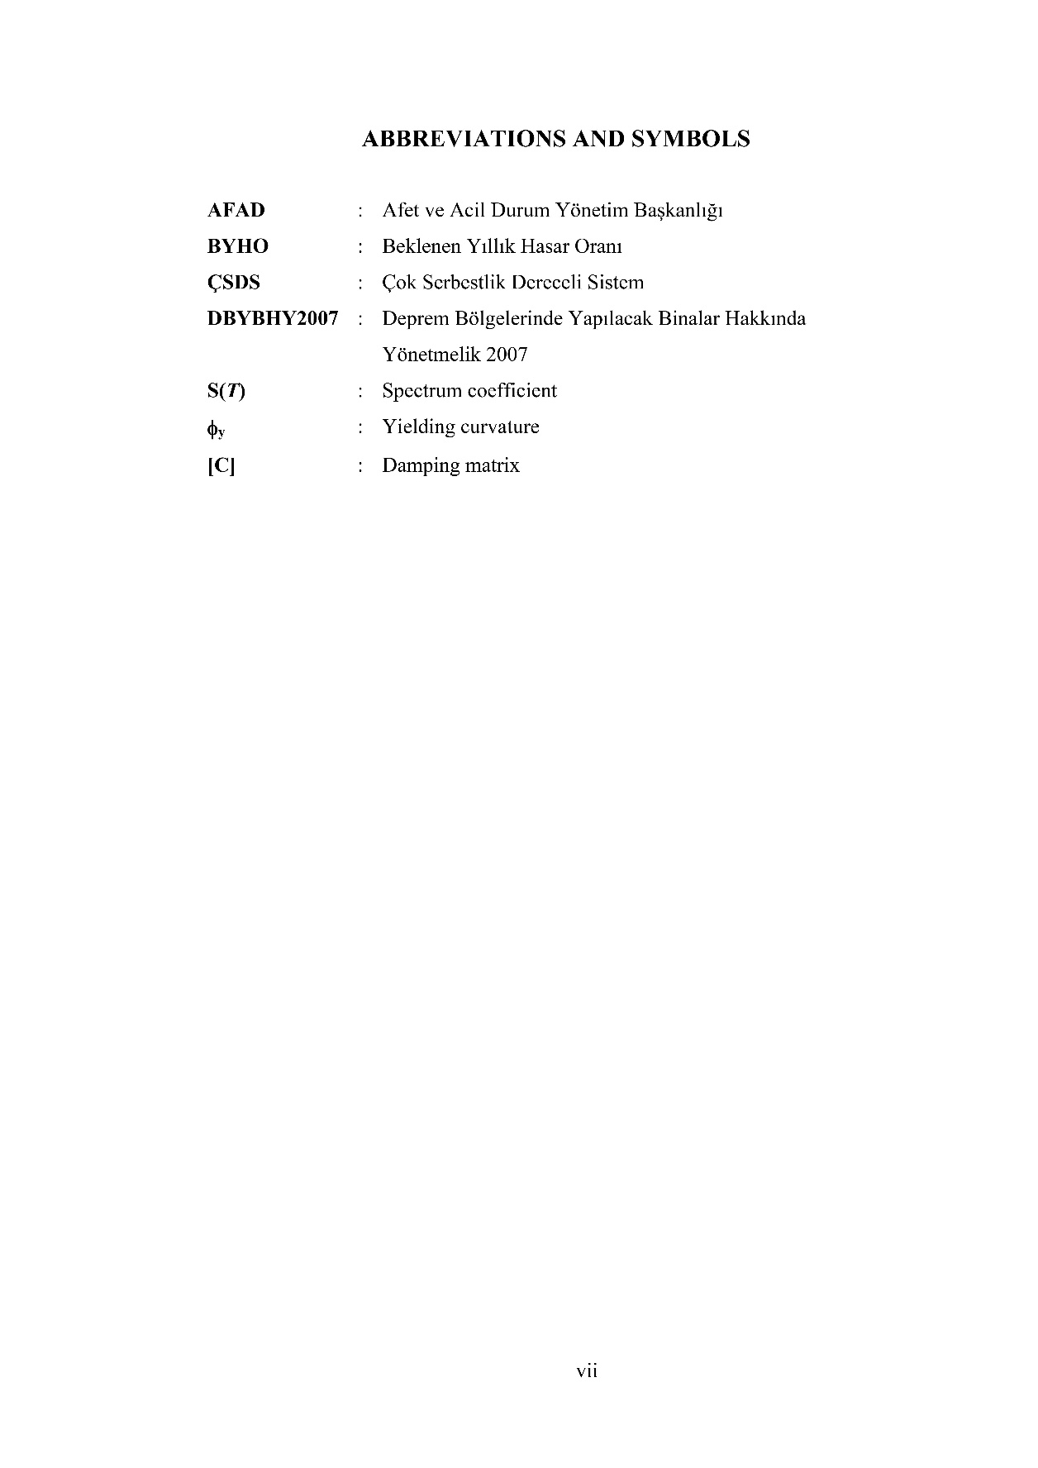
Figure 4.9 Example for abbreviations and symbols page
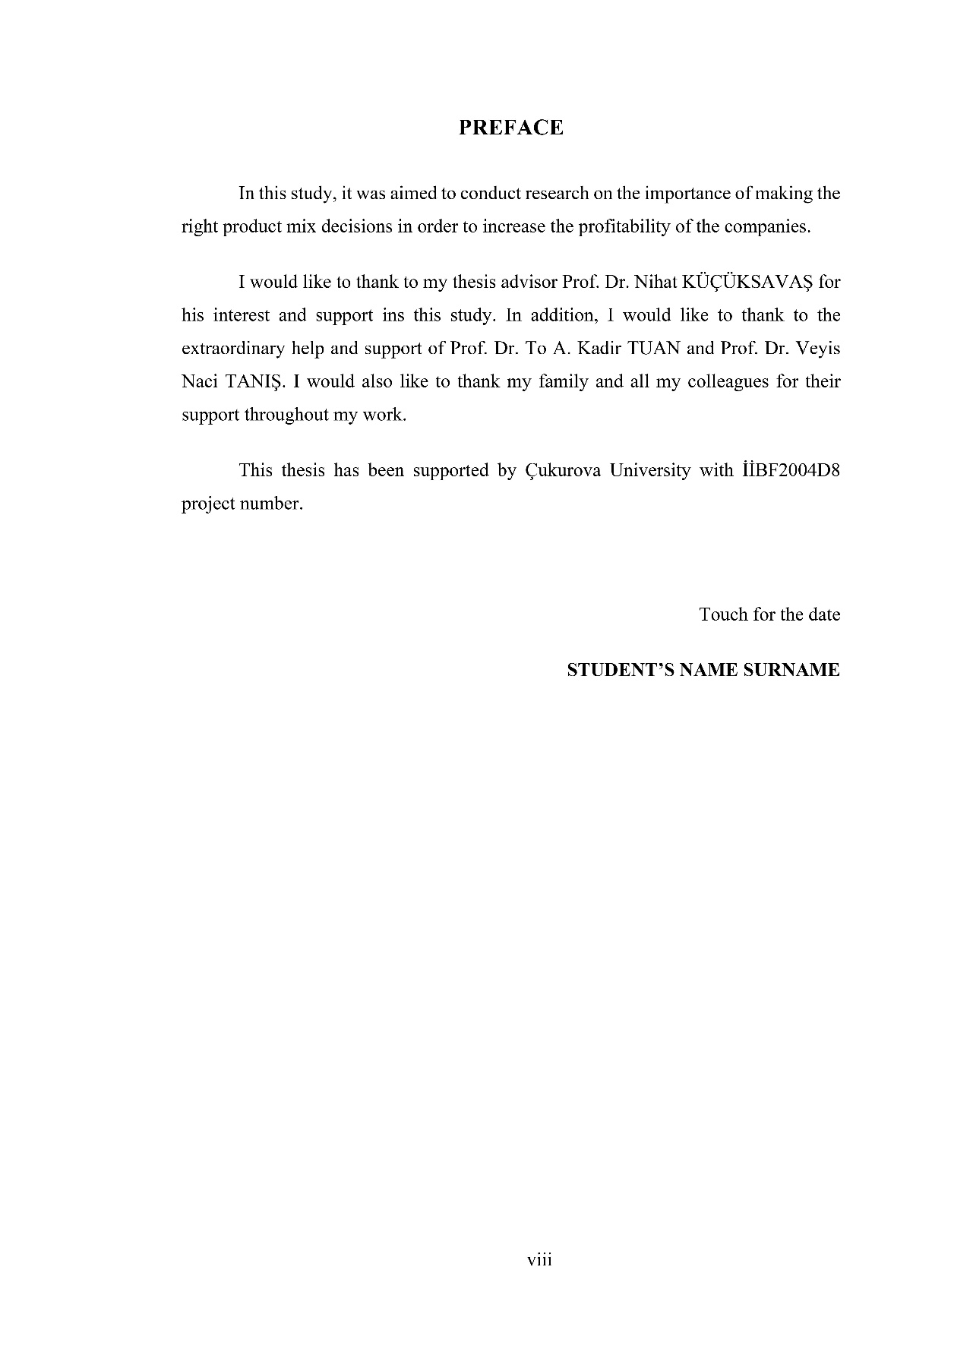
Figure 4.10 Example for preface page

Chapters of Thesis

Introduction
The first part of the thesis/graduation project is “Introduction”. In this section, the subject, purpose, method and structure of the thesis/project are summarized. In the introduction, the subsections of "problem definition", "purpose and scope" and "research method" should be included. In addition, in this section, the presentation of the thesis/project sections is made in the "Organization of thesis" subsection. Example Introduction of different departments is shown in Figure 4.11.

Other Chapters
The other chapters between the "Introduction" and "Conclusion and Recommendations" may vary due to the academic differences in the main science/main arts branches in Graduate School of Istanbul Arel University.

Conclusion and Recommendations
Conclusion and Recommendations section is the last section related to the academic content of the thesis. This section should be written in a concise and understandable way (without copying from the relevant sections), in which detailed and advanced evaluations are made based on the findings of the thesis. The author can mention about the future work and other discussions and/or problems related to the thesis/study. An example “Conclusion and Recommendations” section is given in Figure 4.12.
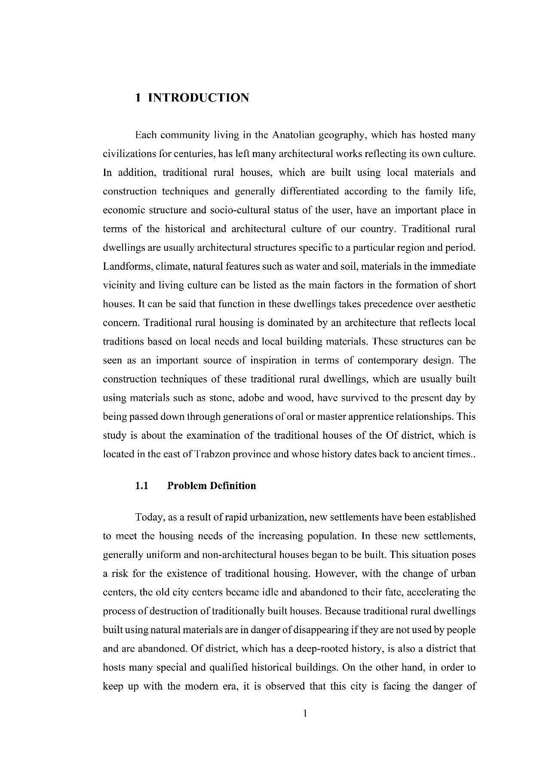
Figure 4.11 Example for Introduction and sub sections -1

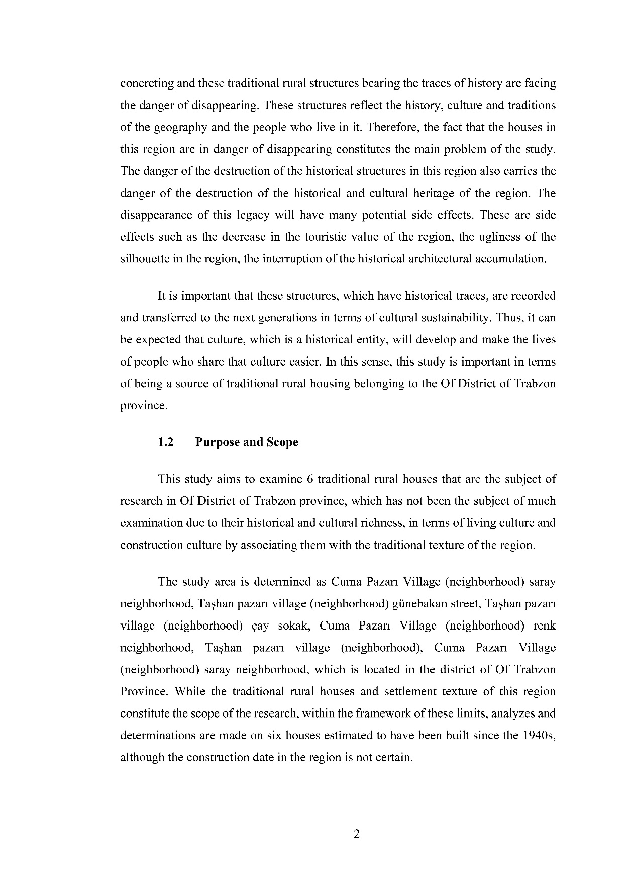
Figure 4.12 continued
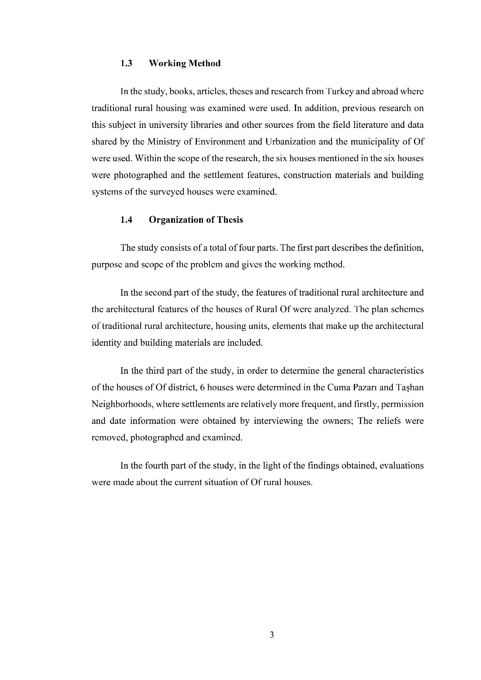
Figure 4.12 continued
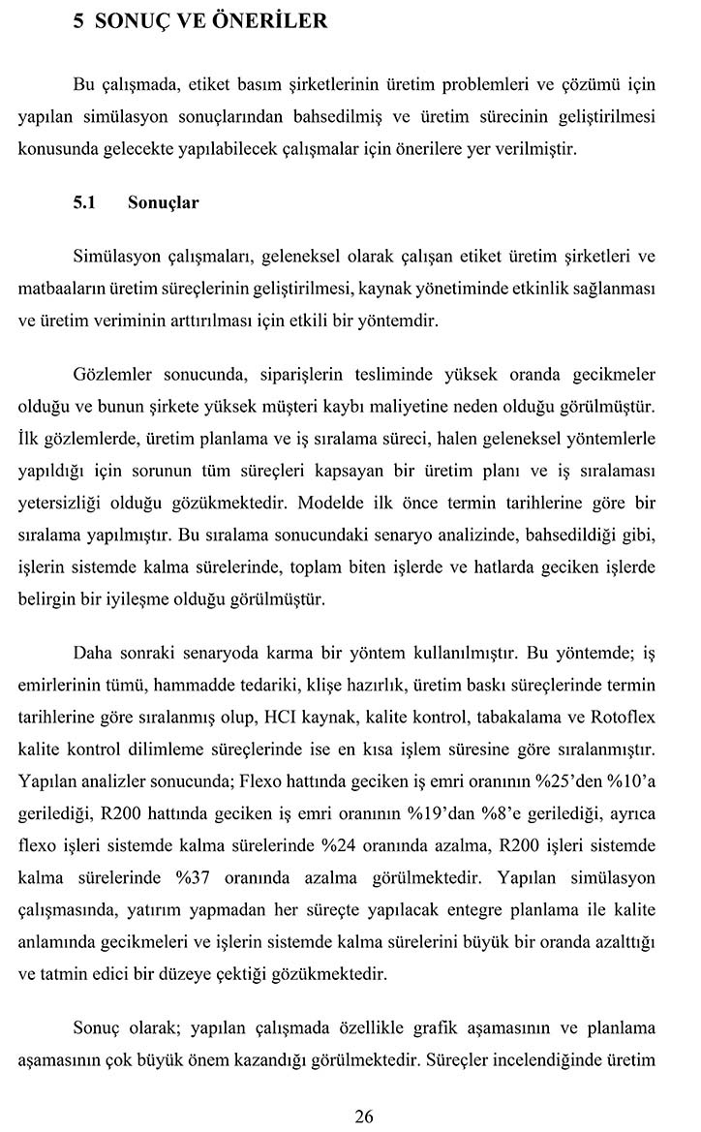
Figure 4.12 Example for conclusion and recommendations page
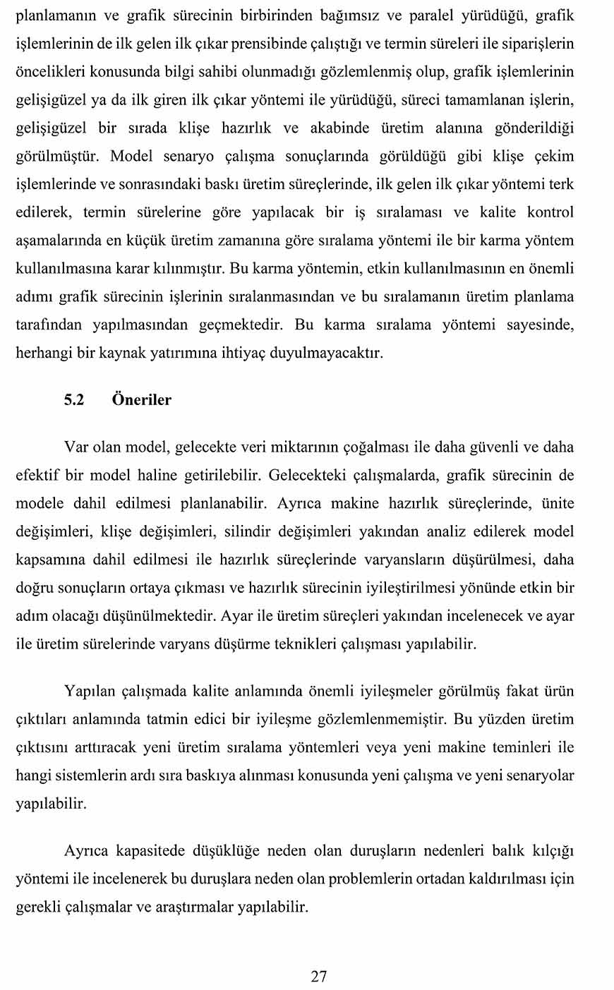
Figure 4.13 continued

METHODS (If any)
The materials used in the research, the preparation of these materials and their properties are explained. In addition, all methods used in carrying out the research are stated in a clear and understandable manner. If there is an innovation or change in known method, these changes should be explained in detail. In addition, the statistical method or methods used in the evaluation of the data are also specified in this section.
This section is not necessary for all thesis.
Delete these comments after this section is prepared.

FINDINGS (If any)
Due to the academic diversity in the major science/arts branches in the Graduate School of Istanbul Arel University, the "FINDINGS" section is not necessary for all thesis.
The obtained findings of the study should be explained by comparing with other studies and relationships and/or differences (if any) between the other studies should be stated. Delete this information after preparing the section.

CONCLUSION AND RECOMMENDATIONS
Conclusion and Recommendations section is the last section related to the academic content of the thesis. This section is the section where the results of the thesis/study and their evaluations are given as short and understandable as possible without repeating (copying from the relevant sections). The author can discuss about the future work and other discussions and/or problems related to the thesis/study. In addition, the author can also make recommendations for future work in this section.
Delete these comments after the section is prepared.

Conclusions

Recommendations

REFERENCES
Aydınlı, M. (2006). Pazarlama Araştırmaları. Ankara: Seçkin Yayınevi.
Palanci, M. (2019). Fuzzy rule based seismic risk assessment of one-story precast industrial buildings. Earthqauke Engineering and Engineering Vibration. 18, 631–648.
Ankara Üniversitesi. (2006). SBE, Lisansüstü Tez Yazım Kuralları. http://www.ankara.edu.tr/institutes/sosyal/tez önerisi hazırlama yonergesi.html (10 Ocak 2011).

This chapter is the last chapter that should be in all theses and all references are given in an index in this chapter. The chapter number may change according to the number of main chapters in the thesis. Create this page according to the reference writing rules suitable for your field. The reference that is not mentioned in the text of the thesis should not be included in the Reference list and the sources should be given in their original language as much as possible. The title of the page should be prepared as "References" using the "Heading 1" style.
While preparing this chapter, the "Kaynak" font style in the "Styles" section should be used. Citations of references in the text is made according to section 8.1, and the preparation and arrangement of the "REFERENCES" section is made according to section 8.2. (Delete these explanations after preparing the section!)

Citation to References in Main Text
Single Author Book: The surname of the author, the year of publication: the page number is given in parentheses. “....Birçok alt kültür ve karşı kültür alanlarıyla günümüz toplumları çoğulcu toplum yapısını oluşturmaktadır (Eroğlu, 1996: 26).”
Book authored by Two/three authors: Surname of the first author, surname of the second author, surname of the third author (if any), year of publication: page number is given in parentheses.
“….Firmalarda genel üretim maliyetlerinin ürünlere dağıtımında direkt işçilik saati gibi dağıtım anahtarlarının kullanılması, toplam maliyetler içerisinde işçilik maliyetinin yüksek olduğu zaman doğru sonuçlar yaratabilmektedir (Cooper and Kaplan, 1988:22).”
Book authored by more than three authors: Surname of the first author et al., year of publication: page number are given in parentheses.
“....Genel olarak, istatistiksel analiz teknikleri iki amaca hizmet etmektedir. Bunlardan ilki farklılıkların tespiti, diğeri ilişkilerin incelenmesidir (Altunışık et al., 2001:141).”
The quotation of multiple references: Between the parentheses, Surname of the author of the first reference, year of publication: page number; surname of the author of the second reference, year of publication: page number; surname of the author of the third reference, year of publication: page number is given. Authors' surnames are given in alphabetical order.
“..Ekonomik bütünleşmenin başarısı statik ve dinamik etkinliğine bağlıdır (Güran, 1999: 41; Walther, 2002: 426).”
The quotation of Same Author for the same year: A separate letter (a, b, c) for each work of the author should be written next to the publication year.
“…. (Gillespie,1997a: 25; Gillespie,1997b: 58).”
The quotation of authors with the Same Surname: Between the parentheses, the first letter of the first author's name. surname, year of publication: page number; the first letter of the second author. Surname, year of publication: page number”.
“…. (E. Yıldırım, 2001:101; R. Yıldırım, 1999: 23).”
The quotation of thesis: Surname of the author and the year of publication of the thesis in parentheses.
“…. (Top, 1980).”

The quotation of encyclopedia, dictionary: The name of the encyclopedia/dictionary, year of publication, volume no: page number is given in parentheses.
“…. (Britanika, 1997, Cilt 4: 573-584).”
The quotation of web page: If quoting from the website, the surname of the author and u.d. in parentheses. (unknown date).
“…. (Nakip, u.d.).”
If an article is cited from a periodical or non-periodical internet, the surname and year of the author are given in parentheses.
“…. (Nakip, 2007).”
If an author and date is not known from the web source, the title of the document in parentheses, anonymous, u.d. is written.
“…. (Motivasyonda Şartlandırma Kuramı, Anonim, u.d.).”
If the author is an institution, the name of the institution is written instead of the author's surname.
“…. (TÜİK, 2009).”

Organization of References
All references quoted in the text should be included in the references section of the thesis.
Reference list in the references,
- Books, articles and proceedings papers
- Theses
- Resource person, Fieldwork, Newspaper, Encyclopedia etc.
- Internet sources
- Other sources (References not given in this guide)
sorting is recommended. These sections should be listed in order of author surname among the same type of references.

Presentation of Books in the Reference List
Books should be written in the following format in the reference list.
Surname, First letter of name. (Year). Book Name. Print Number. Place of Publication: Publisher.
Aydınlı, M. (2006). Pazarlama Araştırmaları. Ankara: Seçkin Yayınevi.
Ertürk, M. (2011). İşletme Biliminin Temel İlkeleri. 8. Baskı. İstanbul: Beta Yayınları.
Kurtuluş, K. (1989). İşletmelerde Araştırma Yöntembilimi (Araştırma Yöntemleri). İstanbul: İşletme Fakültesi Yayın No: 210.
Books with Two or Multiple Authors:
Ellsworth P.T. , Leith, J. C. (1975), The International Economy. 5th ed., New York: Macmillan.
No Author Name:
Name of Institution. Book Name. Number of Prints (Year). Place of Publication: Publisher.
İstanbul Kültür ve Sanat Vakfı. Bülten. Nisan (2001). İstanbul: Art Yayınevi.
Translated book:
Author Surname, First Letter of Author Name. (Year). Book Name. First Letter of Translator's Name Surname (çev.). Place of Publication: Publisher (year of original publication)
Aliyev, H. (1998). Dünya Siyasetinde Azerbaycan Petrolü. A. Çiftçi ve E. Kocabıyık (çev.), İstanbul: Sabah Kitapları (orijinal baskı tarihi 1997)
Book with Single editor:
Surname, First Letter of Author Name. (Ed.). (Year). Book Name. Place of Publication: Publisher.
Kalaycı, Ş. (Ed.). (2006). Çok Değişkenli İstatistik Teknikleri. Ankara: Seçkin Yayınevi.

Book with Two Editors:
First Editor's Surname, First Letter of Name and Second Editor's Surname, First Letter of Name (Ed.). (Year). Book Name. Place of Publication: Publisher.
Stodgill, M. R. ve Cons, A. E. (Ed.). (1962). Leader Behaviour: Its Description and Measurement. Colombus: Pensilvanya State University.
Chapter from the Edited Book:
Author Surname, First Letter of Name. (Year). “Chapter Title”. Editor's First Letter of Name Surname (Ed.). in Book Name. Place of Publication: Publisher, Chapter Page Range.
Koçak, A. M. (2004). “Kat Hizmetleri Departmanı”. N. Kozak (Ed.). Otel İşletmeciliği içinde. Ankara: Detay Yayıncılık, 67-98.
Prepared:
Author Surname, First Letter of Name. (prep.). (Year). Book Name. Place of Publication: Publisher.
Tanses, F. (hzl.). (2006). Kalkınma İktisadı, Yükselişi ve Gelişimi. İstanbul: İletişim Yayınları.
compilation:
Author Surname, First Letter of Name. (Year). “Chapter Title”, Book Name. First Letter of Compiled Author's Name Surname (cpl.). Place of Publication: Publisher.
Özer, E. (2003). “Türkiye’de Yaygın Ekonomi: Nereden Nereye?”, Ekonomik Kalkınma, Kriz ve İstikrar. A. H. Köse ve F. Şenses (drl.). İstanbul: İletişim Yayınları.

Presentation of Periodicals in the Reference
Single-Author Periodicals:
Author Surname, First Letter of Name. (Year). Title of Article. Journal Name. Volume(issue), Page Range.
Shorter, R. (2000). Trade, Investment and Regional Integration. Finance & Development. 38(4), 14-17.

Periodicals with Two Authors:
First Author Surname, First Letter of Name and Second Author Surname, First Letter of Name. (Year). Title of Article. Journal Name. Volume(issue), Page Range.
Altan, R. ve Baran, D. (2002). Çalışan Memnuniyeti: Ayın Elemanı Uygulaması. Ekonomi Dergisi. 7(22), 11-18.
Periodicals Without Authors:
Journal Name. (Year). Title of Article. Vol. Issue, Page Range.
Kapital.(2001). Economics of Trade and Development. 128, 45-52.

Presentation of Conference (Congress) Papers
First Author Surname, First Letter of Name. (Date). Title of Article. Conference Name. Place of Publication: Publisher, Page Range of Article.
Paksoy, P. (7-11 Eylül 2007). Turizm Ekonomisi. 8. Ulusal Turizm Kongresi Bildiriler Kitabı. Antalya: 145-154.

Presentation of Unpublished Thesis
First Author Surname, First Letter of Name. (Year). Thesis Name, Type of Thesis. Prepared in: University Institute.
Taner, S. (2000). İşletme Kuruluş Yerinin Belirlenmesi. Yayınlanmamış Doktora Tezi. İstanbul: İstanbul Üniversitesi SBE.

Presentation of Internet Sources
Article from Internet Journal:
First Author Surname, First Letter of Name. (Year). Title of Article. Journal Name. Vol(Issue): Page Range. Web Page (access date: day month year).
Wale, T. (2002). International Business Management. Journal of Management 12(2): 190-220. http://www.texshare.edu7ovidweb/ovidweb.cgi (4 Mart 2005).
Internet Periodical - Article from e-Journal:
Author Surname, First Letter of Name. (Year). Title of Article. [Electronic Version] Journal Name. Vol(Issue): Page Range (access date: day month year).
Doe, J. (2003). Role of Indication Basics in the Variety of Property by Psychology Undergraduates. [Electronic Version] Journal of Psychology Research. 3: 110-120 (4 Kasım 2005).

Quotation from Institution's Website:
Name of Institution. (Year). Publication Name. Web Page (access date: day month year).
MEB. (2003). Yıllık Rapor. http://www.meb.gov.tr (10 Ocak 2005).
Document with unknown date from Website:
Document Name. (n.d.) Web Page (access date: day month year).
Multidimensional Model of Customer-based Brand (t.y.) http://scholarworks.umass.edu/gradconf_hospitality/2011/Poster/41 (4 Nisan 2003).

Presentation of Encyclopedias in the Reference List
Author Surname, First Letter of Name. (Year). Subject Name. Encyclopedia Name. Vol. Publication Place: Publishing House.
Sarç, Ö.C. (1973). Milli Gelir. İktisat Ansiklopedisi. Cilt 2. İstanbul: Ak Yayınları.

Presentation of Dictionaries in Reference List
Dictionary Name. (Year). “Subject Name”, Publication Place: Publishing House.
Ansiklopedik Ekonomi Sözlüğü. (1987). “Japon Ekonomisi”, İstanbul: Dünya Yayınları.

Presentation of Scriptures in Reference List
Name of Scripture. Name of Period, Verse No.
Kur’an. Yasin Suresi, Ayet 5.

Presentation of Court Decisions in Reference List
Name of the Court Decision Decision Date Number, Name of the Source where the Decision Was Published, Month Year: Page Range.
Anayasa Mahkemesi 13.4.1971 tarih ve E. 1970-63, K.1971-38 sayılı kararı, Anayasa Mahkemesi Kararlar Dergisi, s.9. Mayıs 1972: 450-455.

Presentation of Newspapers in Reference List
Newspaper with Authors:
Author Name Surname, “Subject Name”, Name of the newspaper, Date (day-month-year), Page Number.
Yılmaz Özdil, “Türkiye Nereye”, Hürriyet, 20 Ekim 2010, s.3.
Newspaper without Author:
Name of the newspaper, “Subject Name”, Tarih (gün-ay-yıl), Date (day-month-year), Page Number.
Hürriyet, “Obezite”, 23 Nisan 2010, s.4.

Presentation of Newspapers Movies or Videos in Reference List
Producer's Name Surname (producer), Director's Name Surname (Director), Movie Name [Movie], Production Place: Producer Company, Year.
Necati Akpınar (Yapımcı), Yılmaz Erdoğan (Yönetmen), Vizontele I [Film], Türkiye: BKM Film, 2000.

APPENDIX (If any)

Appendix A Supplement with thesis (if any)
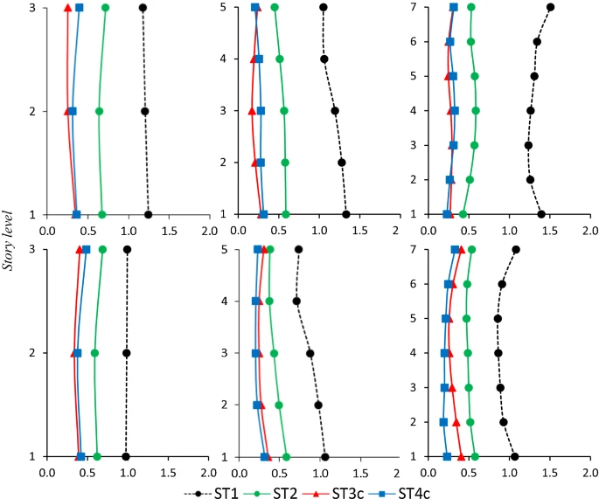
Şekil A. 1 Exemplary figure

CURRICULUM VITAE
Name Surname :
ORCID : Go section 3.7.2.1 to learn how to get ORCID number.
Education
2000 − 2004 | BsC: İstanbul Arel University– Electric-Electronics Engineering
2004 − 2006 | MsC: Istanbul Arel University– Electric-Electronics Engineering
Whhen filling out the table above, it should be filled in the order of degree, starting from the undergraduate to the top. Nnumber of rows can be increased if needed. These notifications should be deleted when the “CURRICULUM VITAE” section is completed.

List of publications:

List of national/international proceedings publications:

