İSTANBUL AREL UNIVERSITY SUMMER SCHOOL APPLICATION

Students who want to take courses from our university must first pre-register in student information system automation. A user account will be opened in the student information system for the students whose pre-registration is completed. Then, students need to register the course from this user account.

Istanbul Arel University summer school application is made at obs.arel.edu.tr/oibs/summer_app/login.aspx.
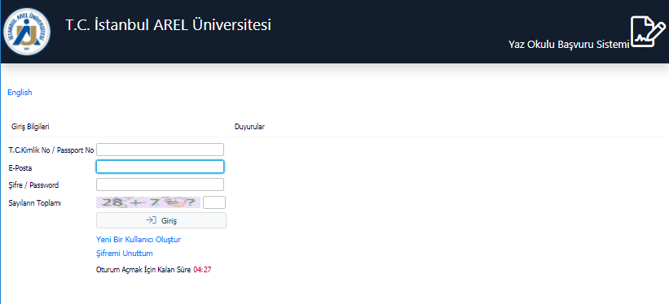
In order to apply, you need to create an account by entering the "Create a New User".
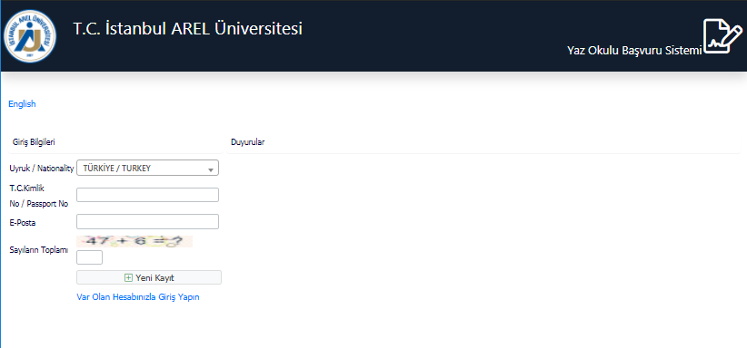
When creating a new user, Nationality, Identity No and e-mail information are requested. It is important that you should write the e-mail address you have actively used since you will receive a passcode.
You can access the system with the password sent to the e-mail address.
After entering the system, the application can be made by selecting "MAKE NEW APPLICATION" from the screen below.
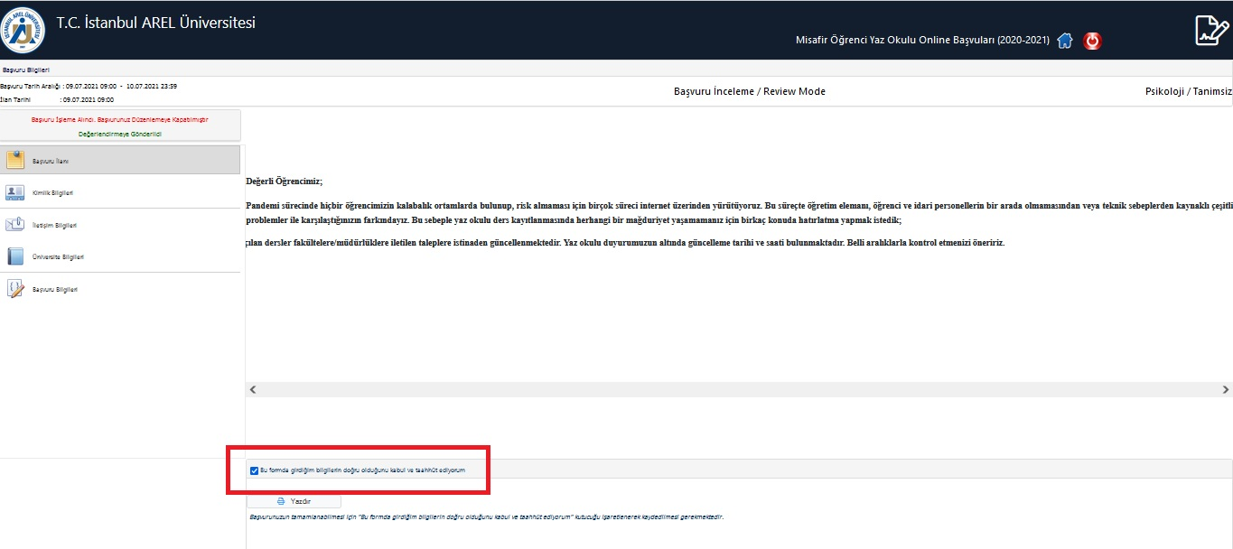
On the application screen, the menus on the left should be followed and the necessary sections should be filled in. The FACULTY and PROGRAM that you want to register from the last menu should be selected.

After all the information is completed, our student affairs unit will create your Student Number as soon as possible by transferring you to our automation system.
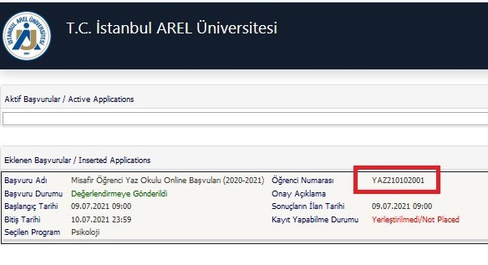
You can then log in to your created user account at https://obs.arel.edu.tr/oibs/ogrenci/ using the information below.
Username: Your Student Number
Password: First 5 Five Digits of Your TR ID Number

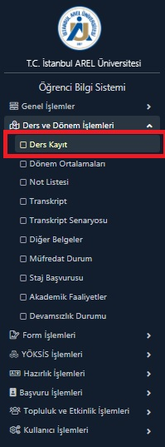
After logging in to your account at https://obs.arel.edu.tr/oibs/ogrenci/, please select "Course Registration" under the "Course and Semester Transactions" tab on the left.
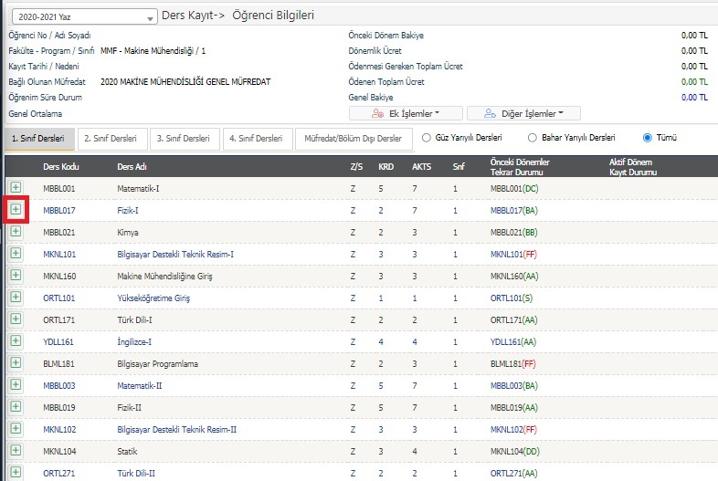
If the course you want to take is opened in the Summer School, click the plus (+) button.

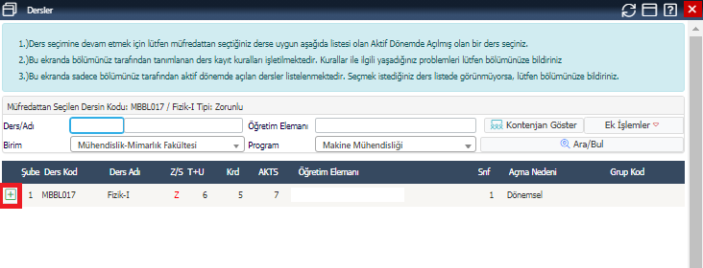
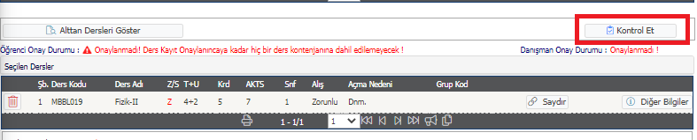
The course you have selected is added to your system in this way. Then click on the "Check" button.

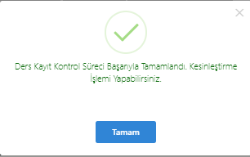
After finalizing your course registration, your academic advisor must approve your registration in order to complete your registration.
You should check the approval status of your course registration by checking the system regularly.

